# Journey through Time: Exploring Ancient and Modern Astronomy

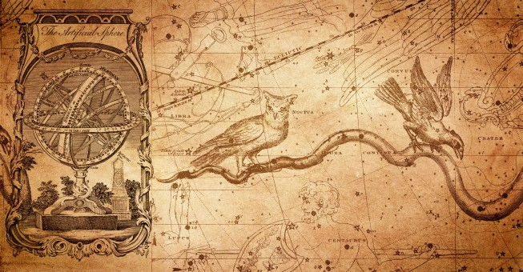

## Introduction:

Throughout history, humanity has been captivated by the mysteries of the cosmos. Ancient civilizations looked up at the night sky with wonder and curiosity, while modern astronomy has unlocked profound insights into the universe. In this blog, we will delve into the fascinating realm of ancient and modern astronomy, highlighting their differences, examining the techniques used, discussing their benefits for humanity, and exploring ways to improve our understanding further.

### 1. Ancient Astronomy vs. Modern Astronomy: A Comparative Analysis

#### Ancient Astronomy:

In ancient times, astronomy served as both a scientific and spiritual pursuit. Ancient civilizations like the Egyptians, Greeks, and Mayans developed their own unique systems of understanding the cosmos. They relied on naked-eye observations, creating intricate calendars, and even constructing monumental structures aligned with celestial events.

#### Modern Astronomy:

Modern astronomy, aided by technological advancements, has revolutionized our understanding of the universe. Telescopes, space probes, and satellites have opened up new frontiers, allowing us to explore distant galaxies, study exoplanets, and detect cosmic phenomena like black holes and gravitational waves.

### Examples and Facts:

- Ancient astronomers, such as Claudius Ptolemy and Nicolaus Copernicus, developed theories about the Earth-cantered and Sun-cantered models of the solar system, respectively.

- Modern astronomy has led to breakthrough discoveries like the identification of exoplanets and the realization that our universe is expanding at an accelerating rate.

### 2. Techniques Used in Ancient and Modern Astronomy

#### Ancient Techniques:

**Naked-eye observations**: ancient astronomers meticulously observed the positions, movements, and patterns of celestial bodies without the aid of telescopes.

**Astronomical instruments:** ancient civilizations developed instruments like the astrolabe and the armillary sphere to measure celestial positions and track time.

### Modern Techniques:

- Telescopes: From the invention of the first refracting telescopes to today's powerful space telescopes like the Hubble and the James Webb Space Telescope, telescopes have significantly enhanced our ability to observe celestial objects.

**Radio astronomy:** The use of radio waves allows astronomers to study celestial objects that emit radio signals, enabling discoveries like pulsars and quasars.

**Space probes and satellites:** Robotic spacecraft and satellites have provided detailed observations of planets, moons, and other celestial bodies in our solar system.

### 3. The Benefits of Ancient and Modern Astronomy for Humanity

#### Ancient Astronomy's Contributions:

**Calendar development:** ancient astronomers developed calendars based on celestial events, aiding in agricultural planning and religious ceremonies.

**Cultural significance:** Ancient astronomical knowledge was interwoven into mythologies, architecture, and cultural practices, fostering a deep connection between civilizations and the cosmos.

#### Modern Astronomy's Impact:

**Technological advancements:** The pursuit of space exploration has driven advancements in various fields, including materials science, computer technology, and telecommunications.

**Understanding our origins:** Modern astronomy has deepened our understanding of the universe's origins, the formation of stars and galaxies, and the potential for life beyond Earth.

### 4. Building a Bright Future for Astronomy

To further enhance our understanding of the cosmos, we can:

**Foster scientific curiosity:** Encourage scientific education and outreach programs to inspire the next generation of astronomers and researchers.

**Collaborative efforts:** Promote international collaborations to pool resources, expertise, and data for more comprehensive and meaningful astronomical discoveries.

**Technological innovation:** Support the development of advanced telescopes, instruments, and space missions to explore new frontiers and push the boundaries of knowledge.

# Conclusion:

Ancient and modern astronomy are intertwined, each contributing to our ever-growing understanding of the cosmos. While ancient astronomy laid the foundation for our fascination with the heavens, modern astronomy has expanded our horizons and brought us closer to answering profound questions about our existence. By embracing scientific curiosity, fostering collaboration, and advancing technology, we can continue our remarkable journey of exploration, opening doors to new discoveries and benefiting humanity in ways we have yet to comprehend.